Week 7 Project – PowerPoint – All About Me

Standards to be covered:

- Transfer skills of usage of one software application to another of similar types [Word to PowerPoint] (TO4a)
- Transfer skills of usage of one hardware to another [one digital camera/scanner to another] (TO4b)
- Use appropriate software to create an electronic presentation [PowerPoint] (CI2.8a)
- Use brainstorming software in planning, prewriting, and organization [???] (CI2.10a)
- Use principles of design in presentation [proportion, balance, contrast, rhythm, unity] (CI2.8d)

---------------------------------------------------------------------------------------------------------------------

Project Directions

This week we are jumping into the wonderful world of PowerPoints. This is something that most students have been doing since they began school. It is not uncommon for most 6th graders to have completed at least 5 PowerPoints at this stage in their lives. However, there are many design principles, slide show tactics, formatting tricks, and other aspects of designing slideshows that may not have been addressed at this point. The purpose of this project is to familiarize students with designing and formatting techniques that are extremely useful, incredibly cool, and really handy in making a dynamic presentation.

The cheat sheet is available on the class website, and the tips there are valid in ALL Microsoft programs.

- Open Microsoft Internet Explorer. Since most students are familiar with the basics of creating a PowerPoint, we are going to start with a basic template that will be downloaded from our class website.

- Go to http://smms-computerliteracy.tripod.com

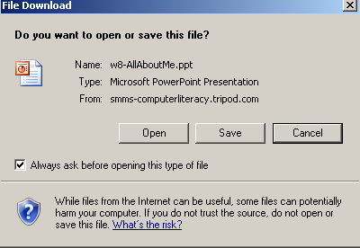
- At the bottom of the website, you see the student section. In Week 7&8, click on the link that says All About Me Base PowerPoint.

  - You will be given the option to Open or Save.

  - If you select Open, Internet Explorer will simply run the slideshow. Do not click Open.

  - Click Save using next week’s filename w8-yourlastname.

  - If you are in class, save it to your I: drive, again use the filename w8-yourlastname. We will not be turning this in until the end of next week. If at home, you need to save it where you can work on it and then bring it to class.

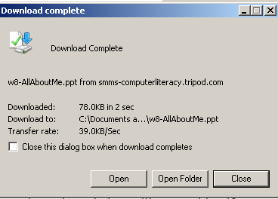
  - After it has saved, another window will open asking if you want to Open, Open Folder, Cancel.

  - Click Open. This will Open the template PowerPoint in Microsoft PowerPoint so that you can begin to edit it.

- Once it is open in Microsoft PowerPoint, you will need to begin to edit the document. Each slide is asking for a different piece of information. In filling in this information, keep several points in mind:

  - Please use complete sentences for everything you type. That includes capitalization, punctuation, and grammar usage.

  - Delete the question that is being asked, and replace it with your answer.
    - For Example, on slide 2, it says “Name”. You would replace name with “My name is Ima Student.”

  - Each slide contains examples of information that needs to be on that slide.
    - Not all slides apply to all students.
    - Not all information applies to all students.
    - For example, on slide 3, where it talks about “If you do not live with your family, tell about who you do live with.” If you live with your family, obviously this does not apply to you so simply delete it.
    - As much information as possible should be entered onto each slide.
    - NOTE: If you do not have any pets, nor do you want any, you MAY delete this slide…but this slide only.
    - If you have any questions, please email me at hmcelroy@camden.k12.ga.us.

  - AFTER all information is entered in on every slide, now it is time put in pictures and clipart. Inserting pictures and clipart into PowerPoint is done the EXACT same way as we did it into Microsoft Word.
    - On slides #2 (Introducing Me) and #3 (About My Family and Friends), you must put in pictures of yourself, and those you live with. Email me if there is a problem with this.
    - On all other slides, if you do not have pictures of you doing your hobbies, your favorite subject, you with your favorite band, etc., then go online and find pictures and clipart of these different things.
    - ALL SLIDES MUST HAVE A PICTURE OR CLIPART THAT IS RELEVANT TO THAT SLIDE’S TOPIC.

- Save it to your I: drive. Again, be sure to use NEXT week’s file name (w8-yourlastname), because this project will NOT be turned in until the end of next week.

