Week 6 Project

Standards to be covered:

- Create doc. using desktop publishing [wizards, help guides: ex. Flyers, brochures, cards] (CI2.6a)
- Use of design principles to convey meaning/message [proportion, balance, contrast, unity, emphasis on points] (CI2.6b)
- Integrates charts & graphs into Word (CI1b)
- Save Internet document as text into Word [save, copy, paste] (CI2.9e)
- Save Internet graphic & insert into Word (CI2.9c)

---------------------------------------------------------------------------------------------------------------------

Project Directions

This week we are using the wizards and preset settings to create a business card. This is designed to get students to think about several things: a) the fact the Word can be used for more than just typing reports and papers, b) to get them thinking about the possibility that they, too, can have a job…mowing lawns, walking dogs, baby sitting, etc., c) Publisher is not the only program that can be used to create things such as business cards, flyers, brochures, creating iron-on transfers, etc.

- Think of a business that you could do at your age: Ex. mowing lawns, walking dogs, baby sitting, etc

- Open Microsoft Office Word

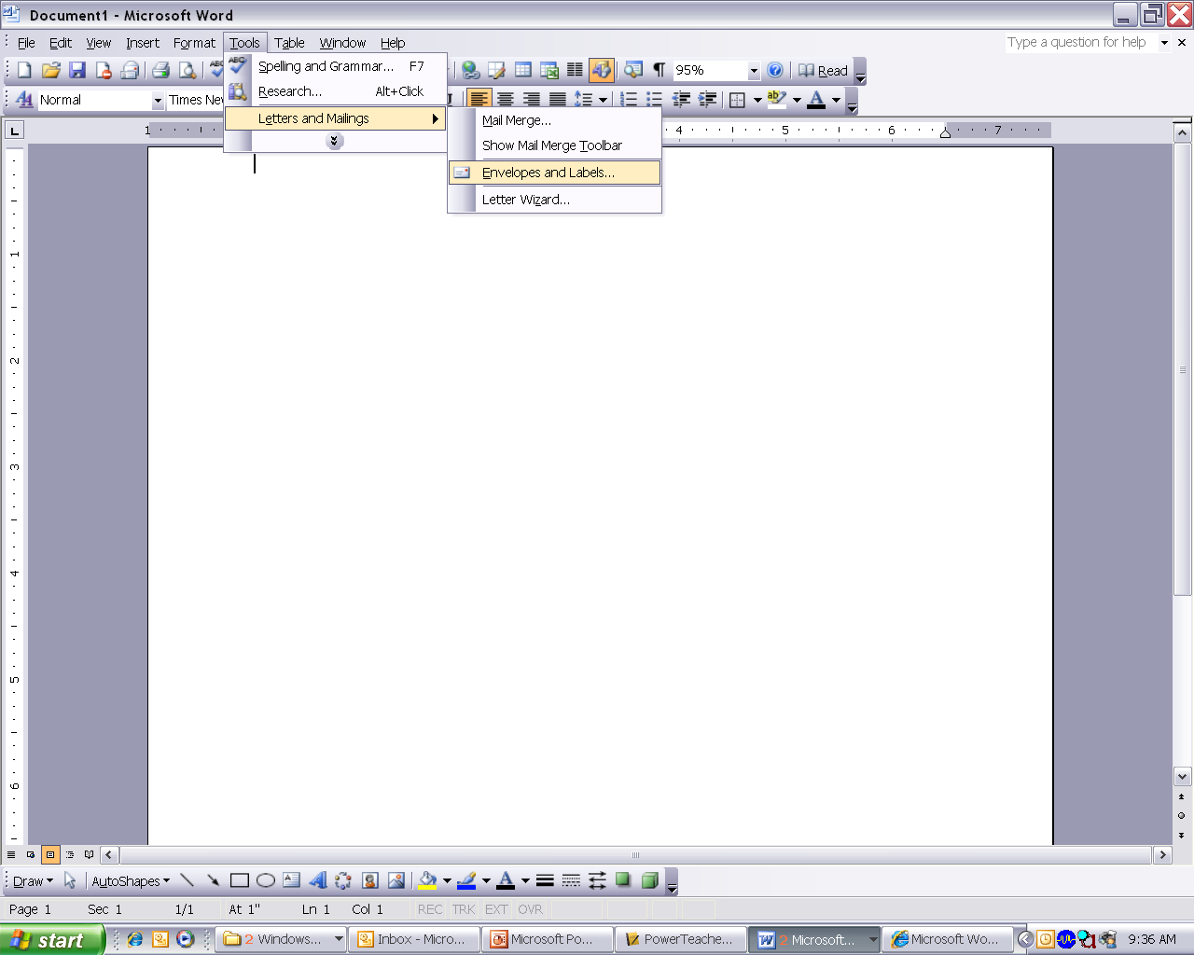
- Click Tools → Letters and Mailings → Envelopes and Labels

- A window will pop up called Envelops and Mailings. The tab for Envelops will be what you are currently sitting on. In the future, the envelop tab will allow you to automatically merge your contact list in your email with this program. After placing envelops into your printer, it will print each person’s address on that envelop. However, for the purpose of this project, we need to click on the tab for Labels.
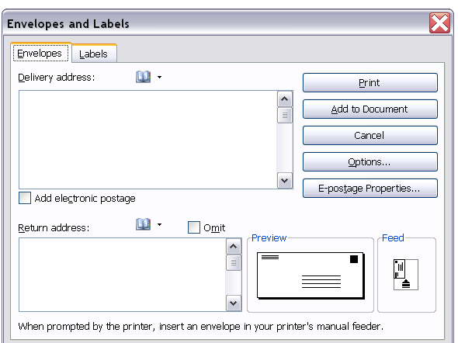
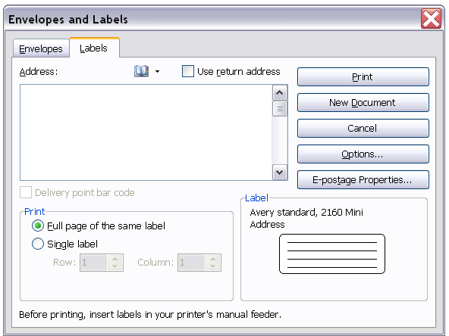

From this
←, click on Labels to get this →

- Notice in the new window where it says Label. The default label that will load is Avery Standard 2160, Mini Address. If you accept this now, it will automatically format Word incorrectly.

Have you ever been to Walmart and seen those packets of labels (labels for return addresses, shipping labels, packing labels, folder labels, and more), business cards, things you can print iron-on transfers, etc.? Each of those packets have programming built into Word, Publisher, and other Microsoft programs. You access that programming this way.

When you go to the Labels section in the window above, you have the “option” to change what type of label the computer will print on. By making this selection, Microsoft will automatically format your document to the label you are using.

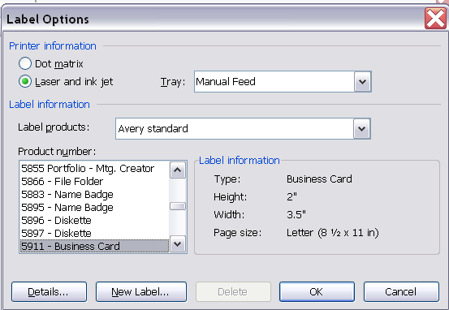
- Now, let’s change the Label from Avery Standard, 2160 Mini Label to the what we are actually doing, a business car.

- Click Options
  - Label Products: needs to be the name of who made your labels you want to make (for the purpose of this project leave it set to Avery Standard)
  - Product Number: needs to be the number on the package of labels you have purchased (for the purpose of this project, find number 5911-Business Cards)
- Click O.K. → click New Document
- After clicking New Document, Windows will automatically format your document to fit the label you have chosen, be it a Name Badge, Return Address, Shipping Label, or a Business Card. In this case, 10 boxes will appear. Each box represents a different card on the sheet of Business Cards.

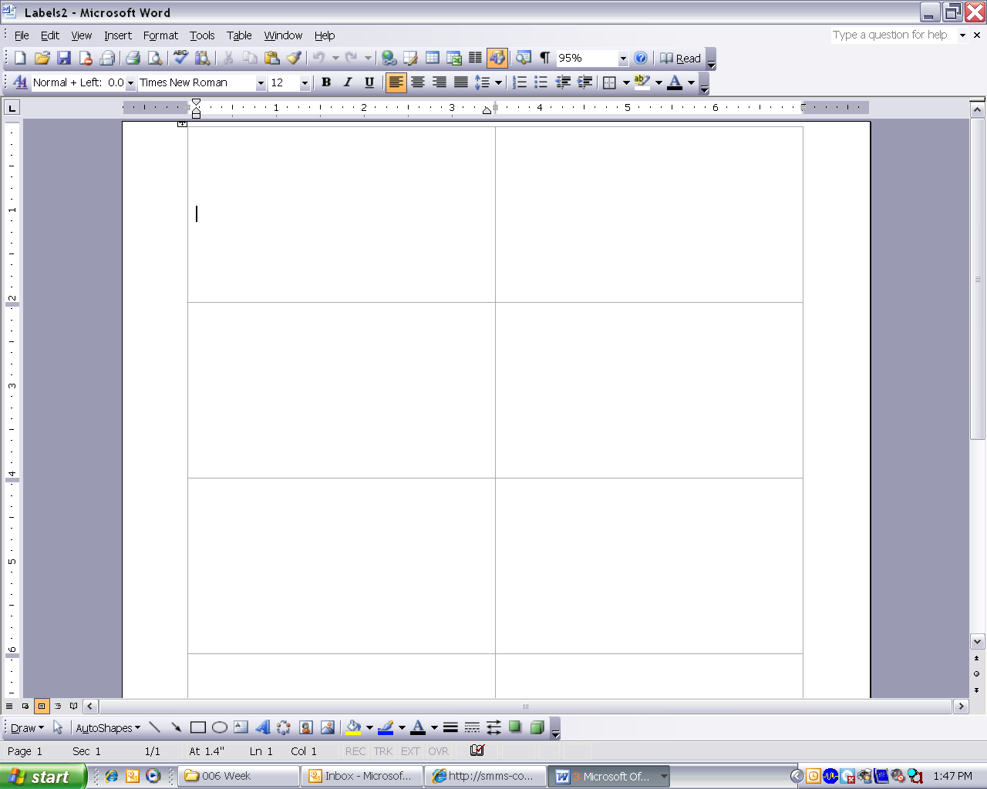

- You only need to format ONE card. From there, we will copy/paste it to all the rest.

- You have chosen your business by now. The first step is to import an image that represents that business. Ex. Clipart of a baby for Baby Sitter, picture of a lawn mower for Landscaping & Lawn Mowing. See example. (This will not be reviewed as it has been covered in previous projects)

- Create a name for your business & a slogan.

- Then include contact information: Name, Address, Phone Number, Cellphone Number, Email. If you are not comfortable putting your real information on there, that is fine. Make something up. Again, see example.

- Save the file first to your I: drive, and then to the O:/McElroy/yourclass# using the filename of w6-yourlastname.

