  Art School  Where art comes to life!  Ima Student  205 Martha Dr.  St. Marys, GA 31558  912-882-8626  istudent@smms.com | 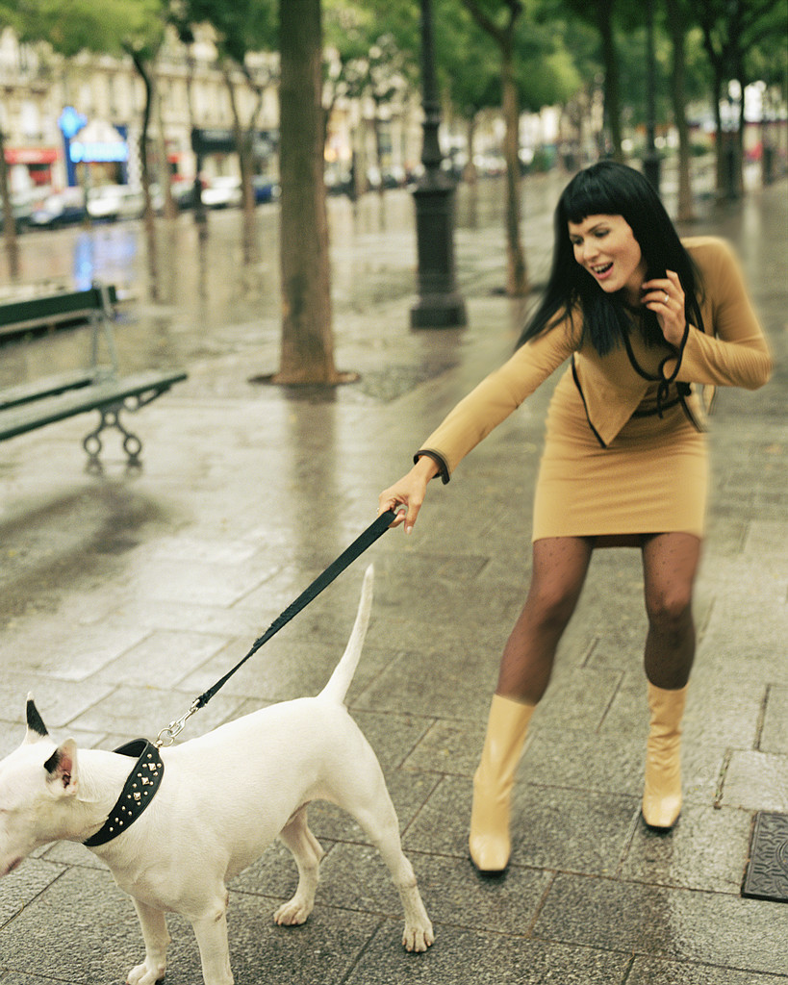  Johnny Student  205 Martha Dr.  St. Marys, GA 31558  912-882-8626  jstudent@smms.com  Student’s Dog Care & Walking  “We walk ‘em when you can’t”
Art School  Where art comes to life!  Ima Student  205 Martha Dr.  St. Marys, GA 31558  912-882-8626  istudent@smms.com | Johnny Student  205 Martha Dr.  St. Marys, GA 31558  912-882-8626  jstudent@smms.com  Student’s Dog Care & Walking  “We walk ‘em when you can’t”
Art School  Where art comes to life!  Ima Student  205 Martha Dr.  St. Marys, GA 31558  912-882-8626  istudent@smms.com | Johnny Student  205 Martha Dr.  St. Marys, GA 31558  912-882-8626  jstudent@smms.com  Student’s Dog Care & Walking  “We walk ‘em when you can’t”
Art School  Where art comes to life!  Ima Student  205 Martha Dr.  St. Marys, GA 31558  912-882-8626  istudent@smms.com | Johnny Student  205 Martha Dr.  St. Marys, GA 31558  912-882-8626  jstudent@smms.com  Student’s Dog Care & Walking  “We walk ‘em when you can’t”
Art School  Where art comes to life!  Ima Student  205 Martha Dr.  St. Marys, GA 31558  912-882-8626  istudent@smms.com | Johnny Student  205 Martha Dr.  St. Marys, GA 31558  912-882-8626  jstudent@smms.com  Student’s Dog Care & Walking  “We walk ‘em when you can’t”

