Week 4 Project

Standards to be covered:

- Format and edit text in document [font, size, B/U/I, find/replace, delete existing] (TO2l)
- Delete v/s Backspace (TO2i)
- Use Spell/Grammar Check (TO2o)
- Use functions keys to move text w/in the document [cut, copy, paste] (TO2n)
- Use functions of the toolbars and pull down menus [cut, copy, past, insert, save, save as] (TO2a)
- Use of fonts to create legible documents [font color & size v/s background color] (CI2.6c)
- Select font to enhance concept [ex. Presentation of Bill of Rights – use of colonial font] (CI2.6d)

Project Directions:

The title of this project is the Bill of Rights. In this project, we will be typing in the first 10 amendments, known as the Bill of Rights, as they are listed below. Then, we will format our paper and make corrections as necessary.

- Set the left & right margins to .5” and the top & bottom margins to 1.5”
Click File à Page Setup à Top, Bottom = 1.5 & Left, Right = 0.5

- Set the Header. APA format includes the title of the paper and the page number
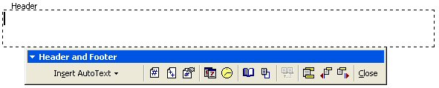

Click View → Header and Footer → Click Align Right → type the title of the paper → click Insert Page Number
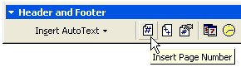

- Set Font Size to 14. You pick the Font Face. Remember design principles: would they have had typewriters in the 1700s? How would they have written the Bill of Rights? How can you make your text match this style as closely as possible?
- Click Align Center and type the title, press Enter twice, then click Align Left .

- Click the Numbers button , or type I. When you press enter, it automatically starts numbering using Roman numerals.

- Enter the Bill of Rights as you see it below.

- Save to your I: drive using the filename: w4-yourlastname (Remember: don’t literally write the words “yourlastname”. You need to key in what your last name is.

Bill of Rights

- First Amendment – Grants freedom of worship, speech & press; the right to petition the government & to assemble peacefully.

- Second Amendment – Secures the right of citizens to bear arms.

- Third Amendment – Guards against unreasonable searches, arrests & seizures of property.

- Fourth Amendment – Assures that troops may not be quartered in private homes without the owner’s consent.

- Fifth Amendment – Guarantees a speedy public trial by an unbiased jury for criminal offenses’ grants legal council for the accused & asserts that witnesses must attend the trial in the presence of the accused.

- Sixth Amendment – Requires indictment by a grand jury for major crimes before trial; forbids repeated trails for the same offense & punishment without due process; prevents people from being required to testify against themselves.

- Seventh Amendment – Guarantees trial by jury in civil cases for anything valued at more than $20.00.

- Eighth Amendment – Prohibits excessive bail & cruel or unusual punishment.

- Ninth Amendment – Declares that powers not delegated to the federal government belong to the states or to the people.

- Tenth Amendment – Confirms that people also have rights other than those mentioned in the constitution

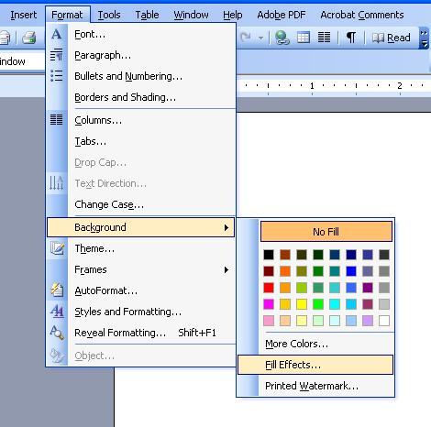
Project Directions (Cont’d):
- Set the background: Click Format → Background
  - Now, you can choose one of the following:

    - Click the new color you want.
    - Click More Colors to see additional color choices.
    - Click Fill Effects to change or add special effects, such as gradients, textures, or patterns.

OOPS!! There is a problem. The Amendments themselves are out of order. The words First, Second, and Third, etc. are correct, but the content behind them is out of whack! Let’s fix them.

- Use the Edit Menu to exchange the content of Amendments 3 & 4.
a. Highlight the text
      - Third Amendment – Guards against unreasonable searches, arrests & seizures of property.

      - Fourth Amendment – Assures that troops may not be quartered in private homes without the owner’s consent.

b. Then click the Edit menu → click Cut
- Put your cursor at the end of the Fourth Amendment (behind consent.)
- Click Edit Menu → click Paste.
III. Third Amendment –

IV. Fourth Amendment – Assures that troops may not be quartered in private homes without the owner’s
consent. Guards against unreasonable searches, arrests & seizures of property.

- Highlight from Assures to consent. → Then click the Edit menu → click Cut
- Put your cursor at the end of the Third Amendment → click Edit Menu → click Paste.
III. Third Amendment – Assures that troops may not be quartered in private homes without the owner’s
consent.

IV. Fourth Amendment – Guards against unreasonable searches, arrests & seizures of property.

- Now, do the same for Amendments 5& 6. However, use the Shortcut Keys (Ctrl+X, Ctrl+C, Ctrl+V) to exchange the content of Amendments 5 & 6.
- Finally, Use the Buttons    to exchange the content of Amendments 9 & 10.
- Save using the file name w4-yourlastname to the I: drive, then save it to O:\McElroy\your class number (Ex. 8-1)

