Week 3 Project

Standards to be covered:

- Desktop functions [switching b/w task, file organization] (TO2c)
- Save document to specific location [save/save as to I: and Y: drive] (TO2d, e)
- Use functions of the toolbars and pull down menus [save, save as] (TO2a)
- Enter text and use line/page break [spacebar, return/enter key] (TO2h)
- Move cursor w/ & w/o use of mouse [mouse & arrow keys] (TO2j)
- Format document [margins, headers, footers, page numbering] (TO2q & CI2.1b)
- Format paragraph [tab, indent, hanging indent, line spacing] (CI2.1c)
- Format and edit text in document [font, size, B/U/I, find/replace, delete existing] (TO2l)

Project Directions:

- Set Margins to 1.5” all around
Click File à Page Setup à Top, Bottom, Left, Right=1.5

- Set the Header. APA format includes the title of the paper and the page number
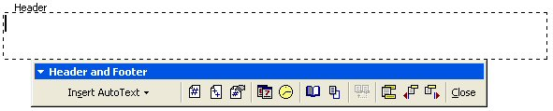

Click View → Header and Footer → Click Align Right → type the title of the paper → click Insert Page Number
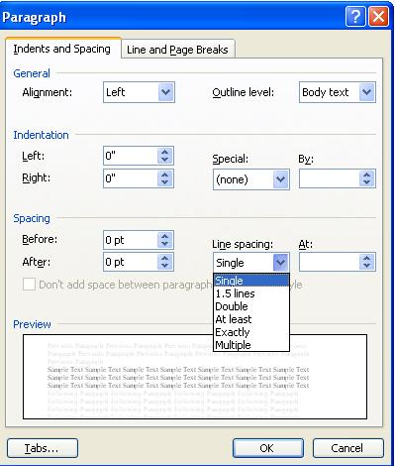
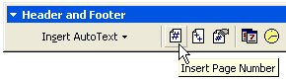

- Set Line Spacing to Double Space
Click Format à Paragraph à Spacing, Line Spacing = Double →→→→

- Type the following:

You are going camping with your family. You have been looking forward to this trip all year. You will be gone for 5 days. Make a list of the most essential items you need to take. You will be carrying everything to the campsite in one trip. Pack wisely.

- Click the Bullets button and list 10 items you would take with you on a camping trip (no electronics other than a radio or flashlight).

- Now, show me what you know how to do. Ex. Change font face, size, background, borders, shading, picture for a background, etc.

- Save to your I: drive using the filename: w3-yourlastname

You are going camping with your family. You have been looking forward to this trip all year. Make a list of all the most essential items you need to take. You will be carrying everything to the campsite in one trip. Pack wisely.
- Toilet Paper & folding shovel
- Radio & Flashlight
- Lighter
- Sleeping Bag
- Camping bag where everything can go
- Book
- Water
- Food
- Clothing
- Compass
- Cooking utensils
- Tent
- Camera

